

**THIRD TERM EXAMINATION - 2020**

**GRADE 11 – MATHEMATICS**

**2 Hours**

**Part - B**

01. A man spent $\frac{4}{7}$ of his monthly income for food, $\frac{1}{7}$ for education, $\frac{1}{4}$ of remainder for other items and the balance saved in the bank.

i. What is the remaining fraction after spend for food and education of total income.

ii. What fraction of the total income did he spent for other items?

iii. What fraction of the total income did he save in the bank.

iv. If he saved a balance of Rs. 1200/- in a bank. Find his monthly income.

v. Show that his monthly saving percentage is more than 20%.

C

D

B

A

M

N

50 m

20 m

14 m

Q

P

02. ABCD is a rectangular shaped garden.

There is a pond in the corner as shown

in the figure. It has made by taking the

Vertex A as the centre of the sector PAQ,

and radius is 14 m.

i. If perimeter of the pond is 39 m show that angle PAQ is 45o.

ii. It is going to be grow grass the garden without the area of the pond. Find the area of grass of the garden.

iii. If a right angle triangular car park is added to inside of garden which has BC as one side of it and other side on CD. Area of the car park is four time the area of pond. ^M is mid-point of CD and MN = 5.8 m). Draw a rough sketch on the above figure to show the car park with measurements.

03. An investor of the share market has invested Rs. 200000/- and purchased 4000 shares.

i. What is the market price of a share bought by the investor. **(02 MArks)**

ii. If he has received Rs. 24000/- as an annual dividend, Find the annual dividend per share paid by the company. **(02 MArks)**

iii. If the investor has sold his all shares, after receiving the dividend for a year. Then his capital gain were Rs. 40000/-. Find the selling price of a share. **(03 MArks)**

iv. If a person who borrowed Rs. 200,000/- paid Rs. 30000/- as interest for a year. Find the annual interest rate that was charged. **(03 MArks)**

04. a). An incomplete table of values and a histogram which represents the marks of grade 10 students in a certain school are given below. Complete the histogram and table.

|  |  |
| --- | --- |
| **Class interval** | **No.of Students** |
| 10 - 20 | 4 |
| _____________ | 6 |
| 40 - 50 | ______ |
| 50 - 70 | ______ |
| 70 - 80 | 6 |
| _____________ | 5 |
| 90 - 100 | ______ |

Marks

14

12

10

No. of students

8

6

4

2

0

10

20

30

50

60

70

80

90

100

40

. Draw frequency polygon using the histogram.

b). Given below is a frequency table of the daily wage of the employees of a certain establishment.

|  |  |  |  |  |  |  |
| --- | --- | --- | --- | --- | --- | --- |
| **Daily wage**  **(Rs.)** | 900 - 1000 | 1000 - 1100 | 1100 - 1200 | 1200 - 1300 | 1300 - 1400 | 1400 - 1500 |
| **No. of**  **employees** | 2 | 5 | 10 | 12 | 8 | 2 |
| **Cumulative frequency** | __________ | __________ | 17 | __________ | 37 | __________ |

i. Complete the cumulative frequency table.

ii. Draw cumulative frequency curve.

iii. Find median daily wage of an employee.

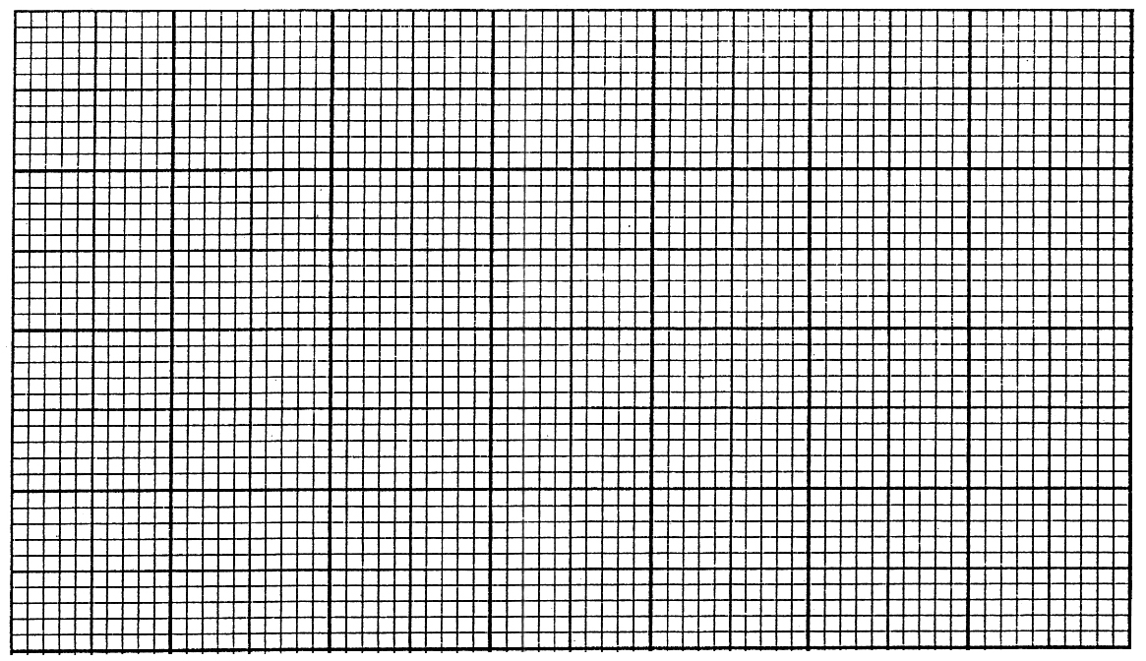

05. a). In a box A, there are two black pens marked B1 , B2 and a red pen marked R1. All pens are of the same site. Nimal drawn randomly a pen from the box, note down its mark, and returns it back to the box. He repeats this process once more.

R

B2

B1

B1

B2

R

2nd taken

1st taken

i. Represent the sample space in a grid.

ii. If M is the event of obtaining two pens of the same colour in the two draws, enclose the event of $μ$ in the grid and Find P ($μ$)

b&' Nimal has another box B, with two red pens and a black pen. Nimal drawn randomly a pen from box A and put it in to box B then drawn randomly another pen from box B.

i. Complete the following tree diagram.

$$\frac{2}{3}$$

$$\frac{1}{3}$$

B

R

B

R

B

R

$$\frac{1}{4}$$

$$\frac{3}{4}$$

ii. Find the probability of getting different colour in both occasion.